Nanakuli JROTC Newsletter
Volume 6, Issue 1 January 2013
Hey cadets! I am
C/LTC Sharon Malano and
This year’s Cadet Battalion
Commander of SY 2012-2013.
It’s been challenging as
Battalion commander of
This school year. Our unit
Has made tremendous
Progress over the years since
I was LET 1, like some of you.
It makes me even more proud
to be from Nanakuli. JROTC
is very unique, it might be
intimidating at first but you should still give it a shot! “JROTC mission is to motivate young people to become better citizens”. Remember to keep the motivation going! The school year is not over yet! Participate as much as you can. Go to the drill meets, ranger events, and keep spring camp in mind. Be on top of your class and keep on track. Make it memorable and ask yourself, “What legacy are you leaving?” Strive on hawks, IMUA!

This year, your cadet chain of command will be as follows:
Battalion Commander – C/LTC Sharon Malano
Battalion XO – C/MAJ Irish Macaso
A Company Commander – C/CPT Jessica Macaso
A First Sergeant – C/1SG Sheldon Ala-Peahi
B Company Commander - C/CPT Nohealani Benicarlo
B First Sergeant – C/1SG Aszalyn Espinosa-Villegas
Battalion S-1 – C/SSG Jason Furuto-Dana
Battalion S-2 – C/SSG Amy Vitale
Battalion S-3 – C/2LT Kevin Green
Battalion S-4 – C/SSG Krysta Pae
Battalion S-5 – C/SSG Raynell Yap-Kahala
Battalion S-6 – C/SSG Summer Yamane

Aloha Golden Hawks!
Both MSG Sagucio “Top” and I would like to welcome all of you back for another exciting new school year here at Nanakuli High & Intermediate School. As your Senior Army Instructor (SAI), I’m truly looking forward to working with you; getting to know each of you, and helping you make the most of your school and JROTC experience.
We ask that you keep the Army Values in mind, as you progress through the school year. Loyalty, Duty, Respect, Selfless-Service, Honor, Integrity, and Personal Courage. Our mission in JROTC is to “Motivate Young People to Be Better Citizens.” This we will ensure by working with you, to help you achieve all of your academic and personal goals.
MSG Sagucio and I have an open door policy, where you can come in to discuss any concerns or recommendations you may have regarding our JROTC program. We are also available to discuss any concerns you may have regarding school or personal matters, if you desire.
Again, looking forward to an outstanding school year here in the Golden Hawk Battalion! Stay motivated, get involved, and think HOOAH! Imua!
- LTC (Ret) Vince Morikawa
Senior Army Instructor

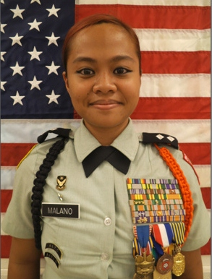

Battalion Drill & Uniform Days
Friday’s 7:30am!
MANDATORY!
JROTC KEY EVENTS
(1st Semester, SY 12-13):
26 January 13 West Point Drill Meet
18 February 13 Great Aloha Run
March Spring Break Spring Camp

Rest in Peace Ramil Musngi Mangubat

Sunrise: January 7, 1995 – Sunset: July 24, 2012

We would like to dedicate one page from the semester news letter to the late cadet Ramil Musngi Mangubat, 17. A senior from Kapolei High School; He was born in San Diego. He survived by parents Raoul G. and Emilda H. The summer of 2009 Ramil and his mother showed up to the Nanakuli JROTC facility asking if Cadet Mangubat could be enrolled in the JROTC twilight course. Kapolei high school did not have a Junior Reserve Officer Training Corps Program so LTC.Morikawa and the Kapolei high school principal agreed to let Ramil attend the after school course for JROTC. Cadet Mangubat was a dear comrade and cadet of the Golden Hawk Battalion. Cadets recognized him as a friendly and smart individual. “He always had a positive attitude, Ramil never complained about the drive from kapolei high school to Nanakuli. He touched many hearts and always put a smile on everyone’s face. He will truly be missed” said cadet MAJ.Macaso. Cadet Mangubat had his whole life ahead of him, future Battalion commander of KHS Marine corps JROTC. Dreaming big and shooting for the stars was never a doubt for the President of the National Honor Society. Ramil accomplished so much out of his short 17 years. “Cadet Mangubat was a bright, caring, and compassionate young leader” Said Lieutenant Colonel Vince Morikawa.

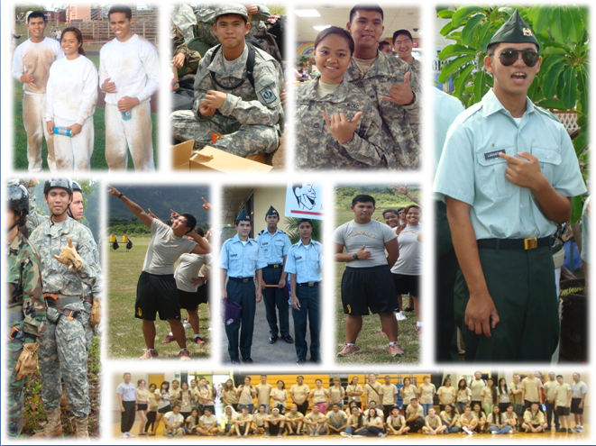
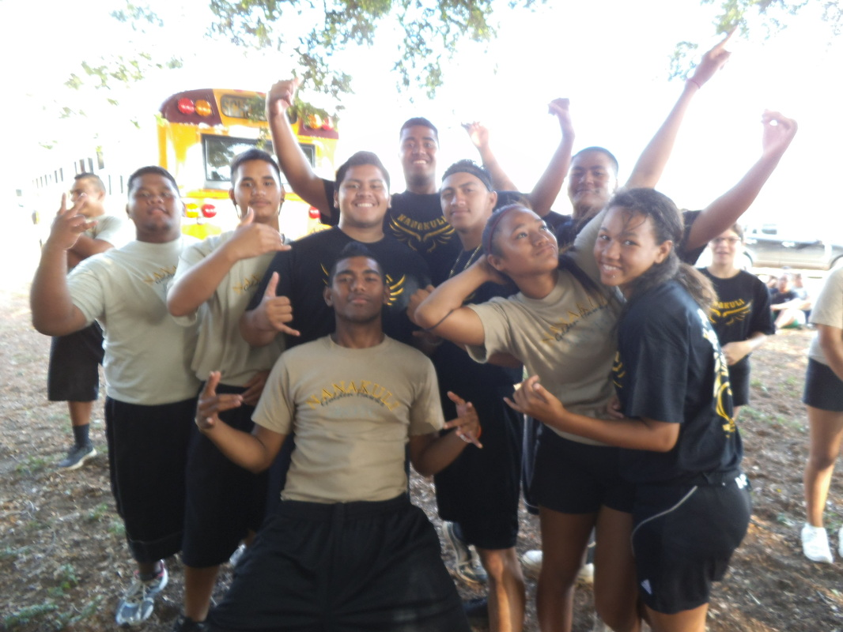
Organization Day
First aid, relay races and tug o’wars helped pull the battalion together in the start of the JROTC program welcoming new and old faces to the 2012-2013 school year. Cadets got to go out to compete in various activities where they learned about teamwork, support and overcoming challenges throughout the day.
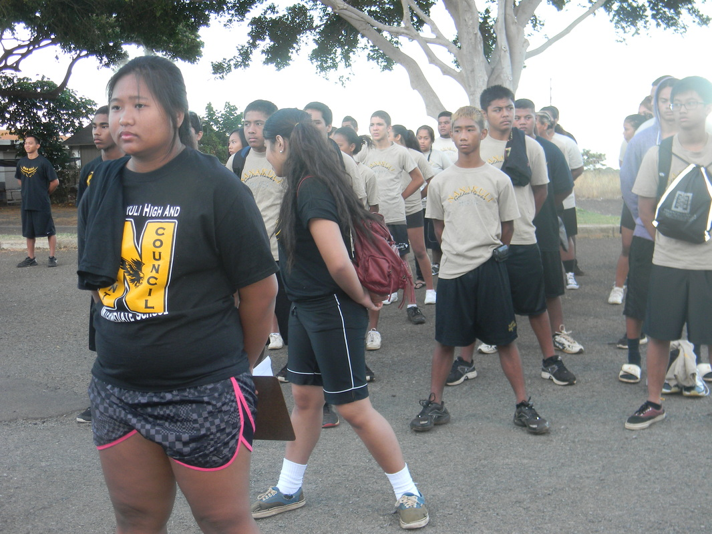

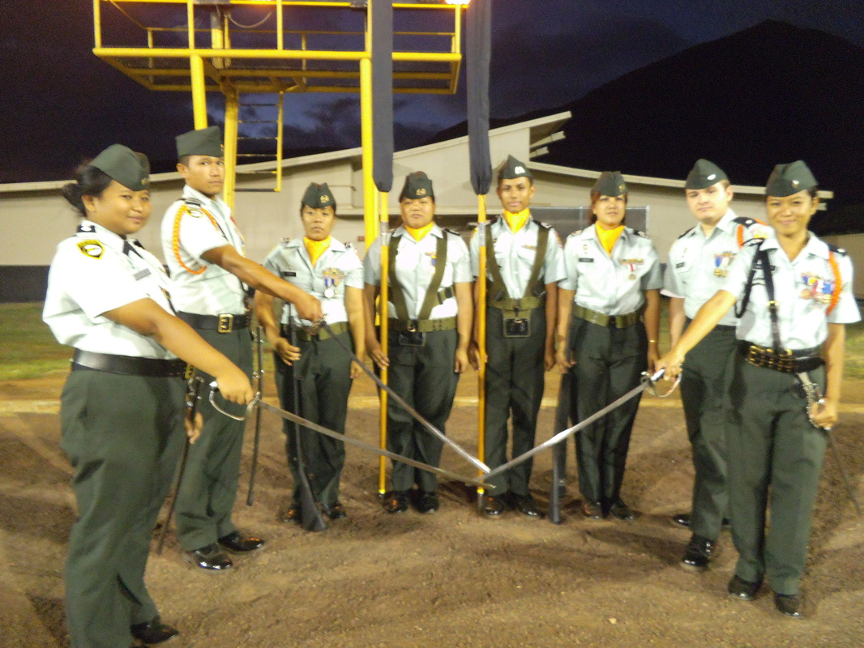
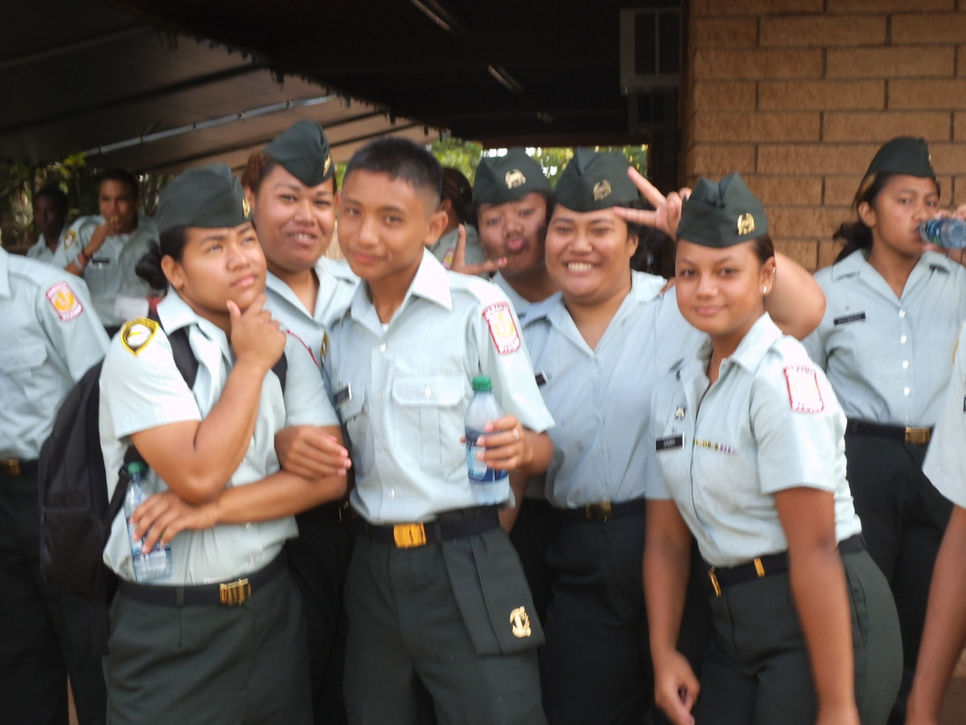
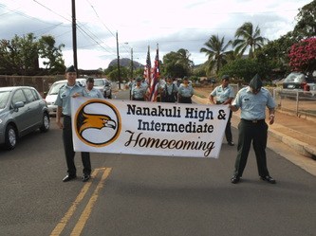
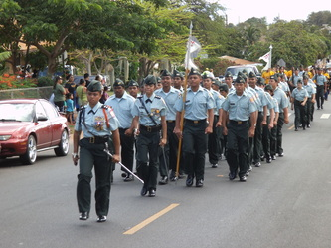
Homecoming Parade
Cadets make their way up the Nanakuli ave leading the way in a huge mass of over 50 cadets. The crowd cheered from the sidewalks after hearing the cadets sound off to the cadence “I said a boom chicka boom!”

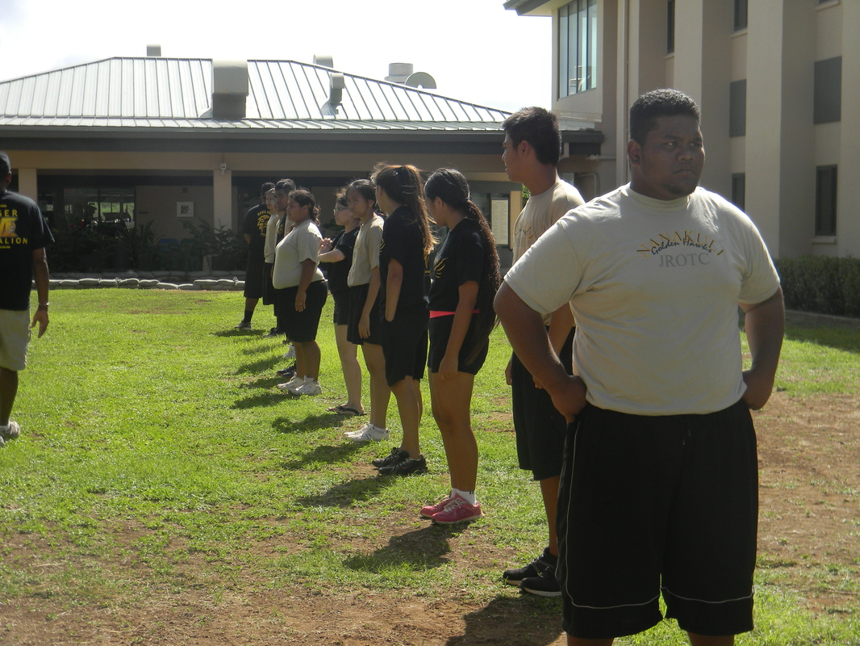
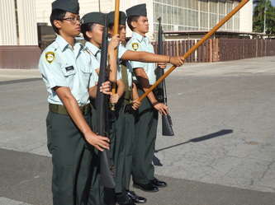
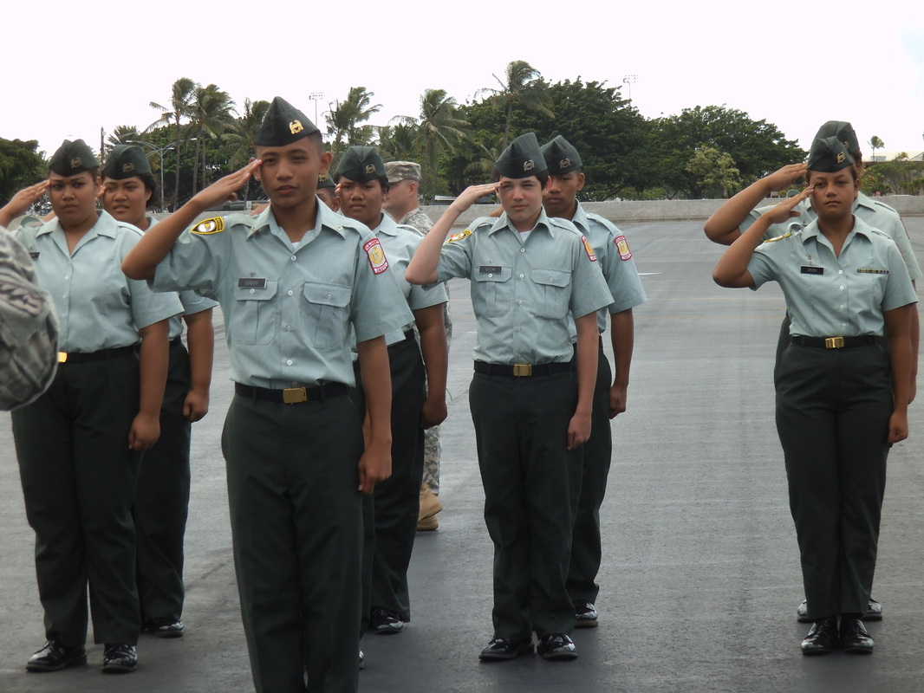

Air Force Drill Meet

LET 1’s got the opportunity to step out of their comfort zone and take the lead in the air force drill meet. The first year cadets in the JROTC program was able to practice in preparation of competing in various drills against rookie teams from across the island.

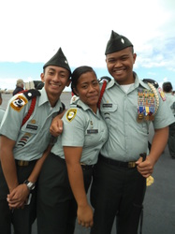

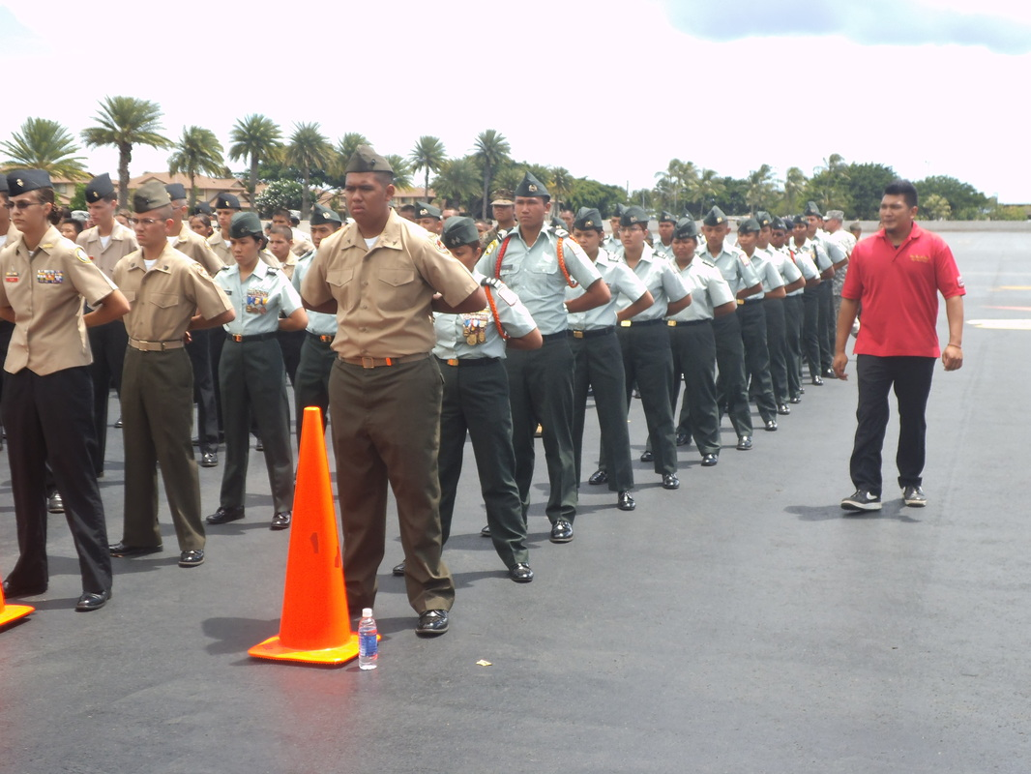

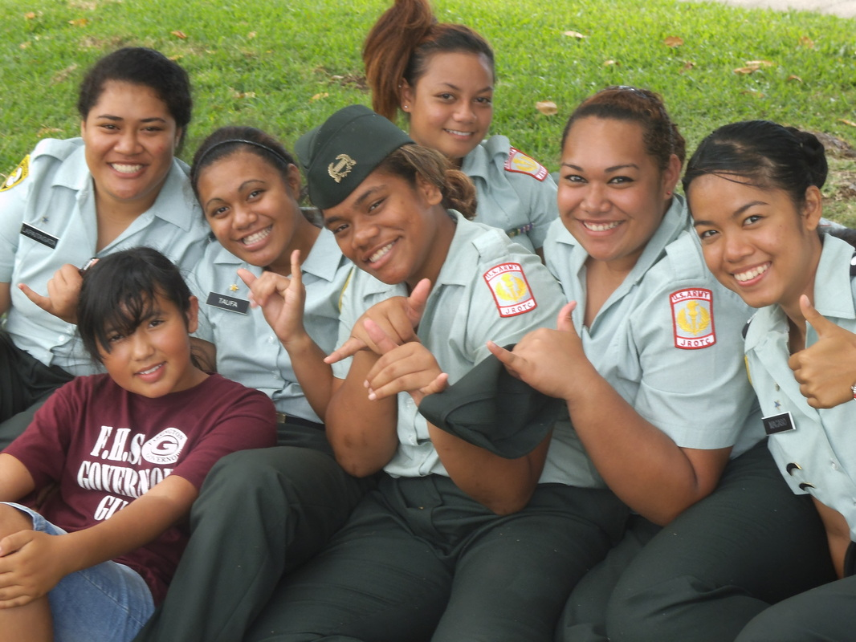

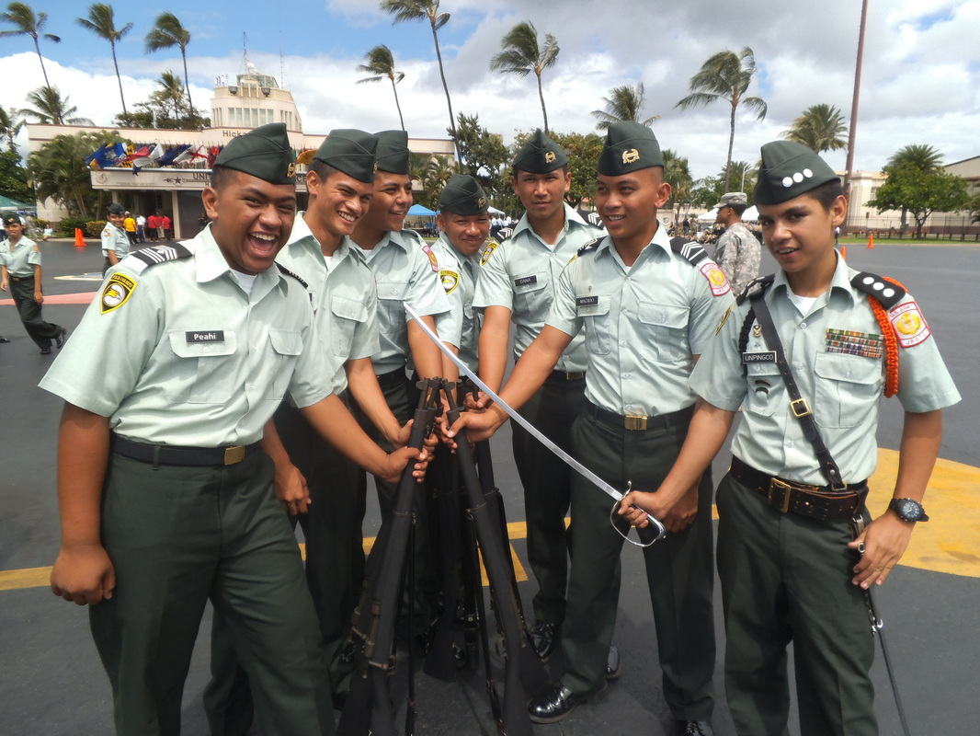

Check out our NHIS JROTC Home Page at:

http://Nanakulijrotc.weebly.com/index.html

Veterans Day Parade/Drill Meet

Cadets march along with the various floats and decorations that walk in remembrance and gratitude in honor of the armed forces. After the March cadets competed in drill graded by the Strategious king’s guard. Though the judges put more pressure on the competitors, Nanakuli’s color guard took home the 2nd place trophy.

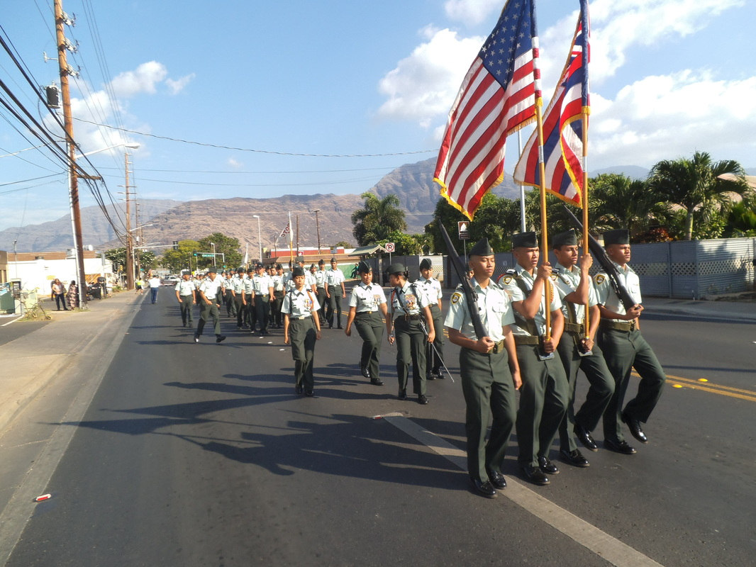

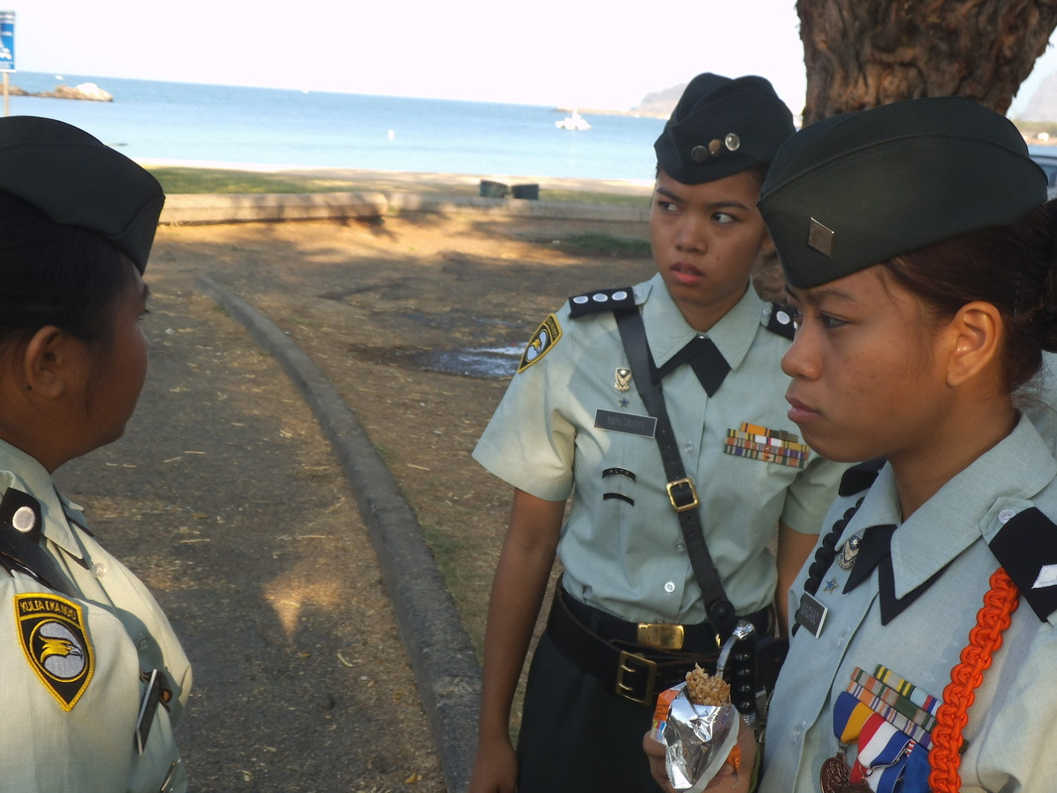

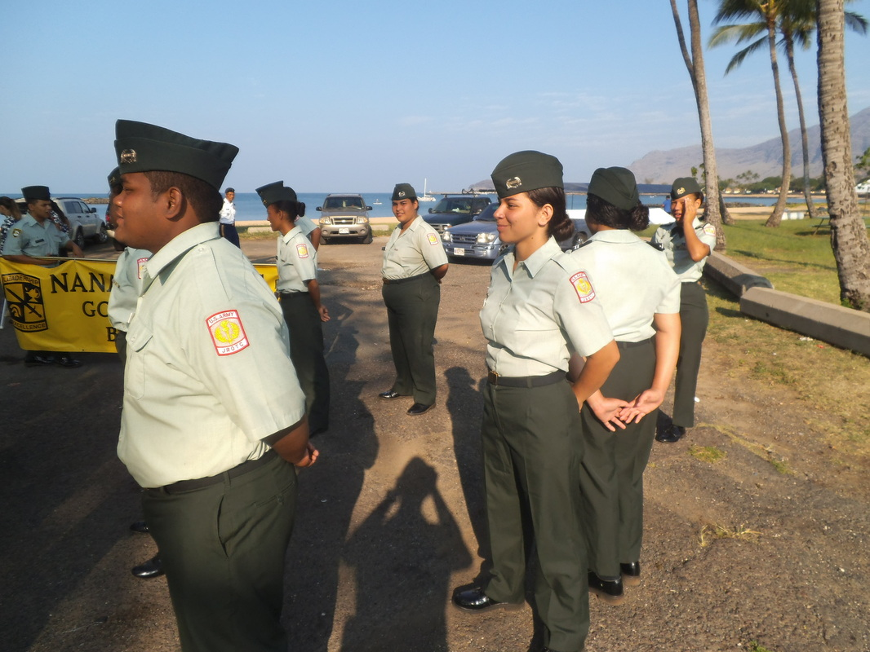

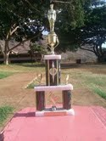
Promotion board

What is promotion board?
Promotion board is the opportunity for cadets that are no higher than a sergeant to be promoted to a higher rank.

In preparation of the promotion board cadets should know, there cadet creed, basic JROTC knowledge and their chain of command.

Come out! And Take on this opportunity on

17 January 13
4 April 13

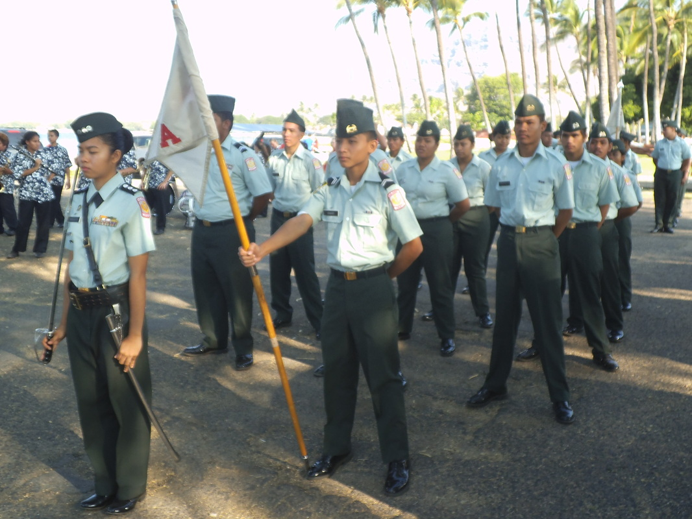
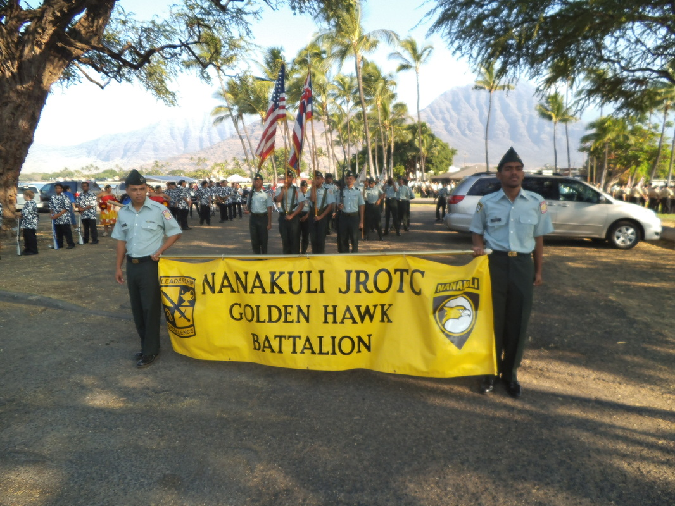

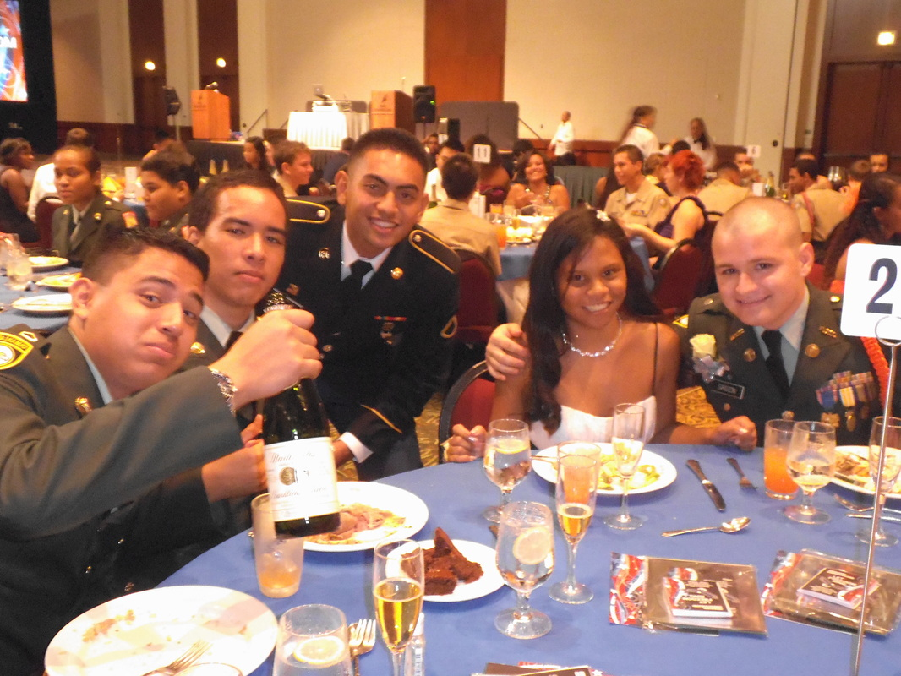

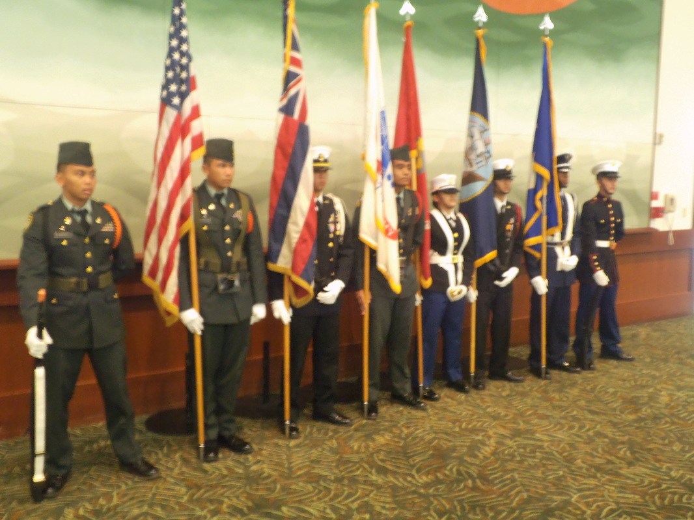

Upcoming Test Dates

SAT
26 January 2013
9 March 2013
4 May 2013

ACT
9 February 2013
13 April 2013
8 June 2013

ASVAB
6 March 2013

*If you have free or reduced lunch you are qualified for test fee waivers. See Mrs.Bailey for more info.
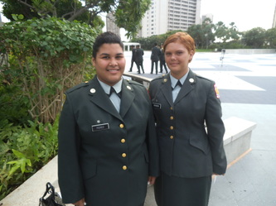
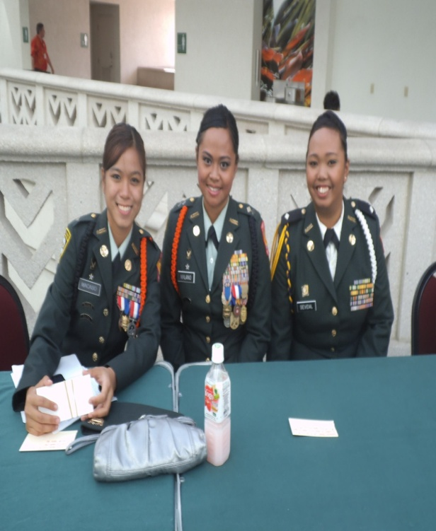
Military Ball
All around the island JROTC cadets gathered together at the Hawaii convention center in Waikiki to “Let freedom ring.” Cadets dressed to the finest of JROTC attire transitioning from their usual class B to class A attire. This occasion brought the special camaraderie between cadets and the program they have all come to love JROTC.

